Abundance of ash across size classes

The average density of ash seedlings ranged from 0 to 5.4 stems/m² (0-54000 stems/ha), with an average of 1.65 stems/m² (16500 stems/ha). Number of short ash seedlings (<25 cm height) averaged 0.88 stems/m² and varied by hydrological class (χ²=12.6, 2 df, p=0.002). Hydric transects had lower numbers of short seedlings than mesic (Z=3.4, p=0.002) and xeric (Z=2.9, p=0.012) transects, while numbers of short seedlings were similar in mesic and xeric transects (Fig. 2A). Number of tall ash seedlings (25-137 cm height) averaged 0.78 stems/m² and differed by hydrological class (χ²=19.1, p<0.001), with hydric transects having lower numbers than either mesic (Z=4.3, p<0.001) or xeric (Z=3.3, p=0.003) transects (Fig. 2A). Mean percentage cover of ash seedlings ranged from 0% to 38.1%, with an average of 10.7% across all transects. Similar to patterns for the density of ash seedlings, percentage cover of ash seedlings varied by hydrological class (χ²=17.7, p<0.001), with hydric transects having lower percentage cover of ash seedlings than mesic (t=3.8, p=0.002) and xeric transects (t=3.3, p=0.006).

The density of ash saplings ranged from 0 to 0.539 stems/m² (0-5390 stems/ha), with an average of 0.046 stems/m² (460 stems/ha). Numbers of ash saplings were similar among hydrological classes (χ²=0.26, p=0.88) (Fig. 2B).

A total of 330 understory ash trees (2.5-10 cm DBH) were found, and of these, 276 were living (canopy condition ≠ 5), while 54 were dead and standing. The density of living understory ash trees ranged from 0 to 1193.7 trees/ha, with a mean of 123.7 trees/ha. The number of living understory ash trees varied by hydrological class (χ²=14.6, p=0.001). Hydric transects had more understory ash trees than xeric transects (Z=3.7, p=0.001) and marginally more understory ash trees than mesic transects (Z=2.2, p=0.078) (Fig. 2C). Of the 330 understory ash trees, 131 were identified as being green, white, or pumpkin ash, while 178 were identified as black ash, and 21 were unidentified Fraxinus (Figure S1). Only 9 canopy ash trees (≥ 10 cm DBH) were found in all the plots, of which 7 trees were living. Living canopy ash trees within the plots ranged in diameter from 10.3 cm DBH to 12.4 cm DBH. The basal area of living ash trees (all ash ≥ 2.5 cm DBH and canopy condition ≠ 5) at the transect level ranged between 0 and 2.60 m²/ha, with an average of 0.24 m²/ha.

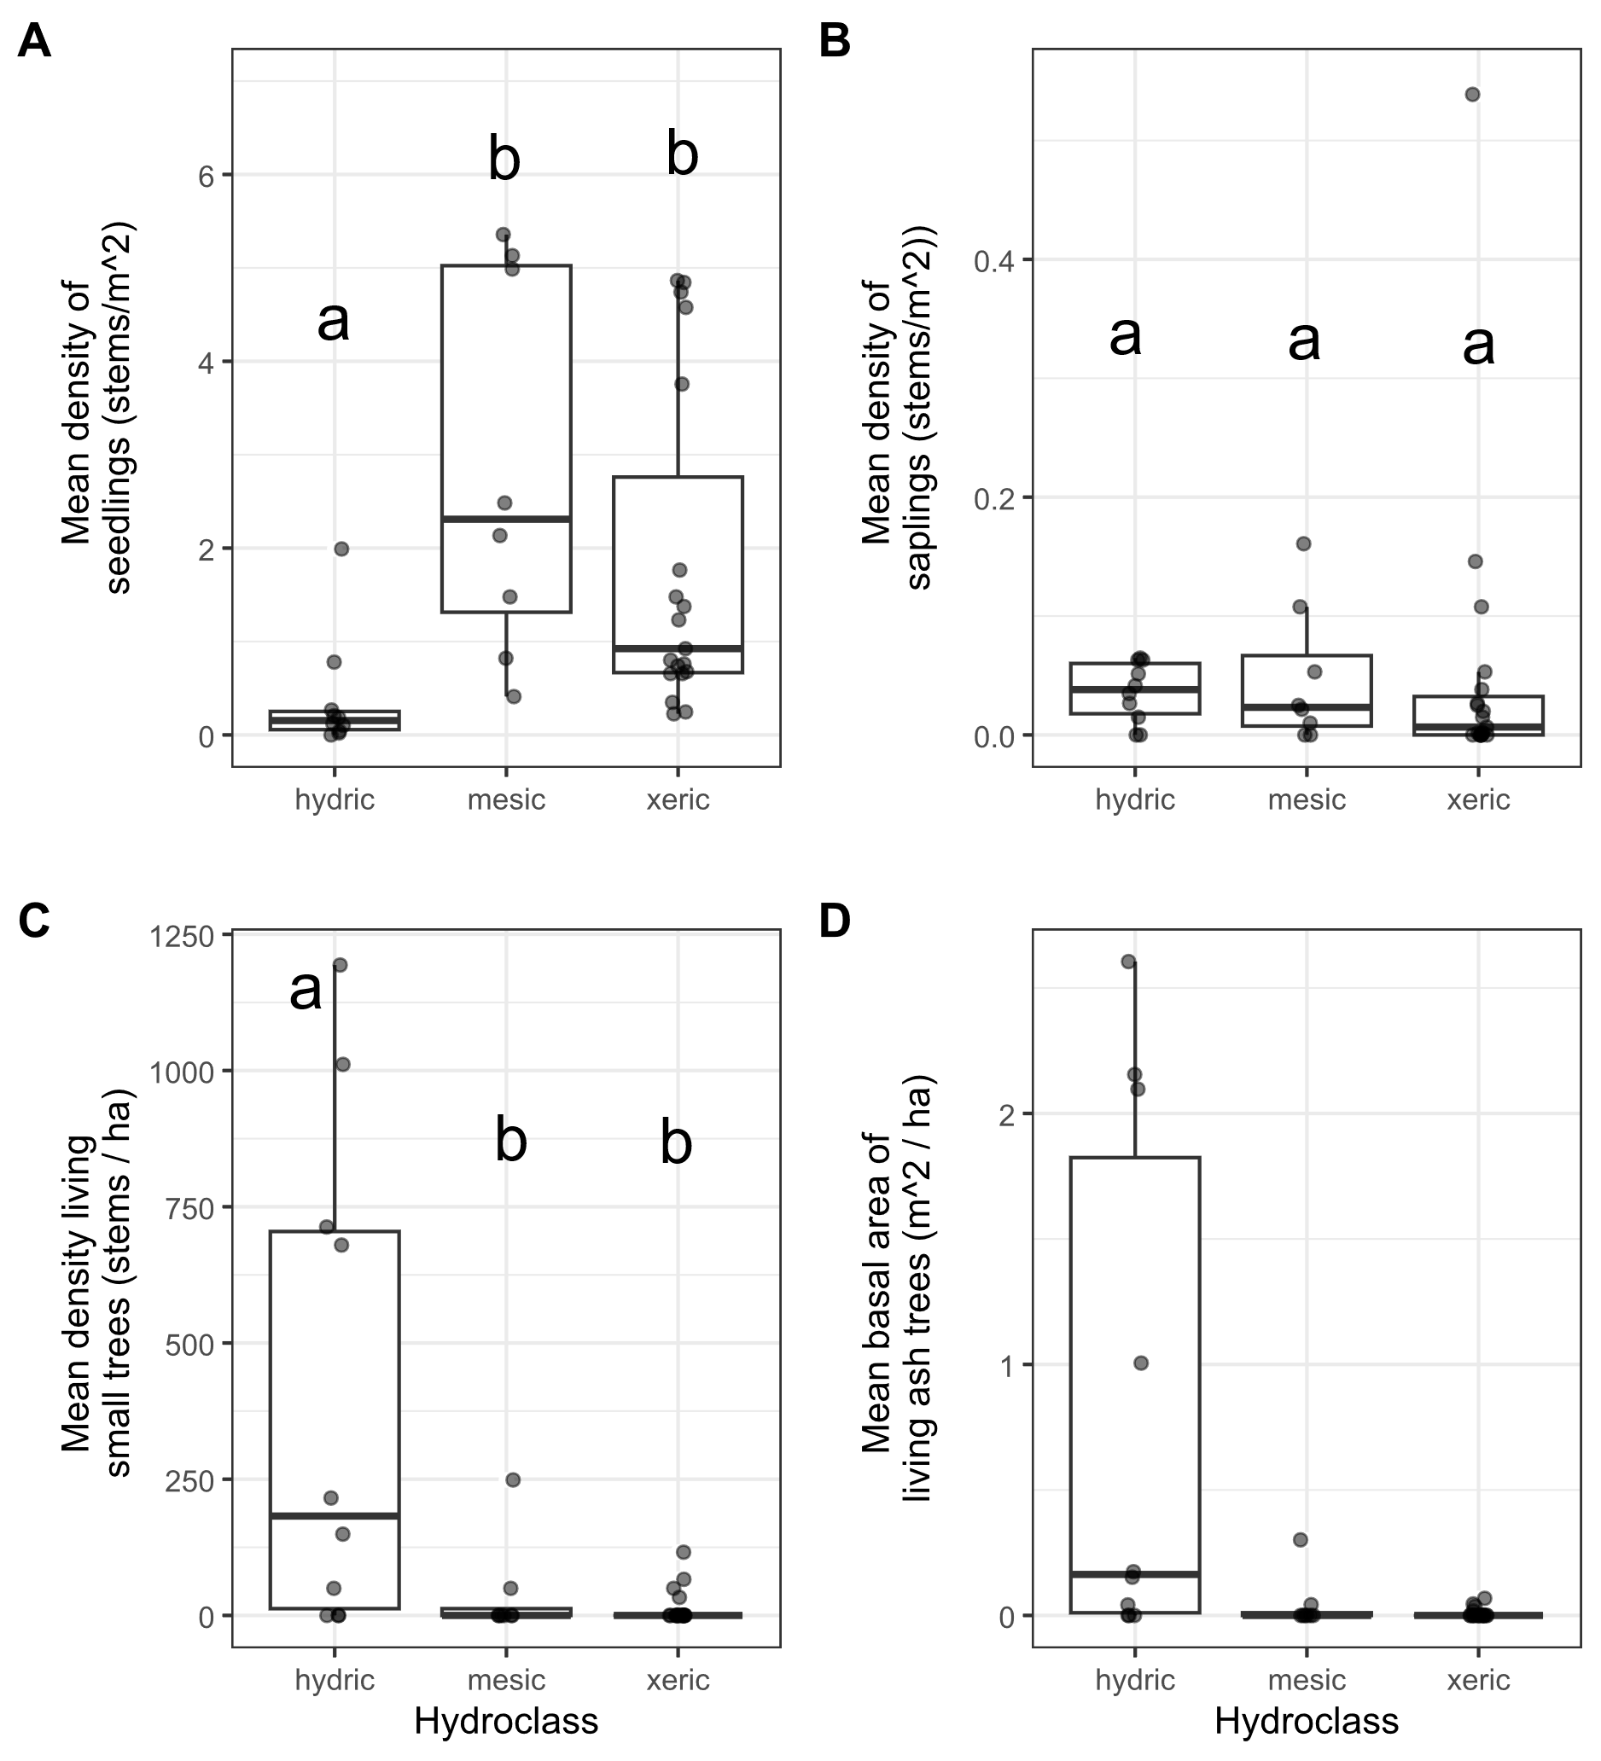
Figure 2. Ash occurrence in 37 transects in the Upper Huron River Watershed in southeast Michigan. The x-axis represents the soil hydroclass of the transect. Each data point represents a transect. Lowercase letters above bars indicate statistically significant differences at α=0.05. A) Mean density of ash seedlings (all ash with height < 1.37 m; short and tall seedling categories were combined for the graph), B) mean density of ash saplings (height ≥ 1.37 m and DBH < 2.5 cm), C) mean density of living understory ash trees (2.5 cm ≤ DBH < 10 cm), D) mean basal area of all living ash trees (DBH ≥ 2.5 cm). The basal area of living ash trees was not statistically investigated.

Table 1. Density (± standard error) of living ash (Fraxinus) regeneration in hydric (10 transects), mesic (8 transects), and xeric (19 transects) forests in the Upper Huron River Watershed in Southeast Michigan, USA. Only living trees are tabulated here. Data were collected in 2024 (97 plots) and 2025 (14 plots).

Size class | Hydrology class | Ash ha⁻¹
Short seedlings (<25 cm tall) | Hydric | 1,334 ± 952
 | Mesic | 15,420 ± 4,920
 | Xeric | 9,895 ± 2,458
Tall seedlings (25-137 cm tall) | Hydric | 2,381 ± 994
 | Mesic | 13,085 ± 2,563
 | Xeric | 8,351 ± 1,625
Saplings (>137 cm tall and <2.5 cm DBH) | Hydric | 360 ± 79
 | Mesic | 472 ± 205
 | Xeric | 517 ± 286
Understory trees (2.5 – 10 cm DBH) | Hydric | 401 ± 145
 | Mesic | 37 ± 31
 | Xeric | 14 ± 7
Canopy trees (>10 cm DBH) | Hydric | 2 ± 2
 | Mesic | 0
 | Xeric | 0

where 95% of all trees were ash, Our study plots differ in that ash had a relative density of only 22% on average (ranging from 6% to 62% of the tree stems in a plot) (Smith 2006). The competing non-ash trees in our study plots likely limited the ability for basal sprouts of ash trees to grow and continue to produce seeds.

Although we found many established ash seedlings, we found very few new ash samaras or newly germinated ash seedlings within our plots, and those that we did find were in hydric transects. We did observe two individual ash seedlings with cotyledons in 2025 at Island Lake, and in 2024 we observed isolated examples of ash seed production by four trees in the vicinity our study plots. Three out of four were black ash in hydric plots, and the diameter of the three seed-producing black ash trees ranged from 6.57 cm to 11.5 cm. Thus, we found that ash tree reproduction is still rare.

We found that even where ash seedlings were abundant, newly germinated seedlings were almost absent in 2024-2025 (we only found two individual seedlings with cotyledons at one site). After the near-complete elimination of ash trees > 2.5 cm in diameter in 2009 at our transects, production of viable seeds ceased and germination of new ash seedlings plummeted (Klooster et al. 2014). Fifteen years later, established ash seedlings persist, but the absence of new seeds means the ash seedling layer is not being replenished.

